**BURCHARD GALLERIES**

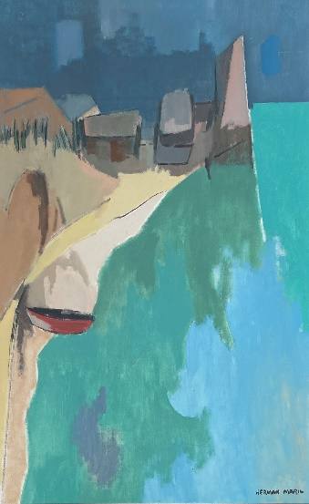

**1200) Large Herman Maril Modernist Coastline Painting**

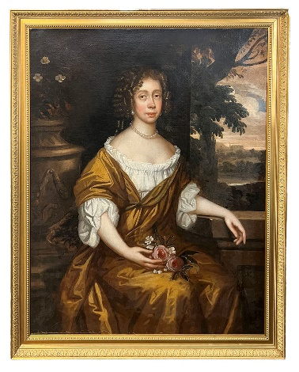

**1031) Lady Mary Neville After Sir Peter Lely**

**AUCTIONS**

**Saturday December 16th**

**Sunday December 17th, 2023**

**Estate Antiques Fine Art & Jewelry**

000 Lots! 2 Days Long, 2 Days Strong. Lifelong assemblages from Astute Collectors and Many Museum Quality Treasures.

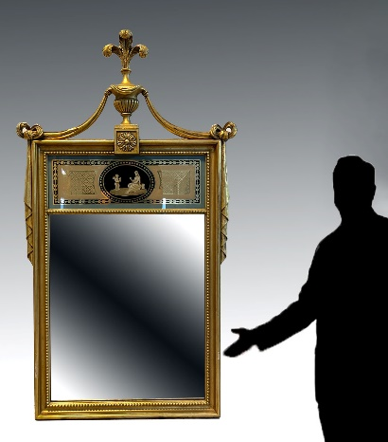

**1396} Finely Carved & Gilded Wall Mirror**

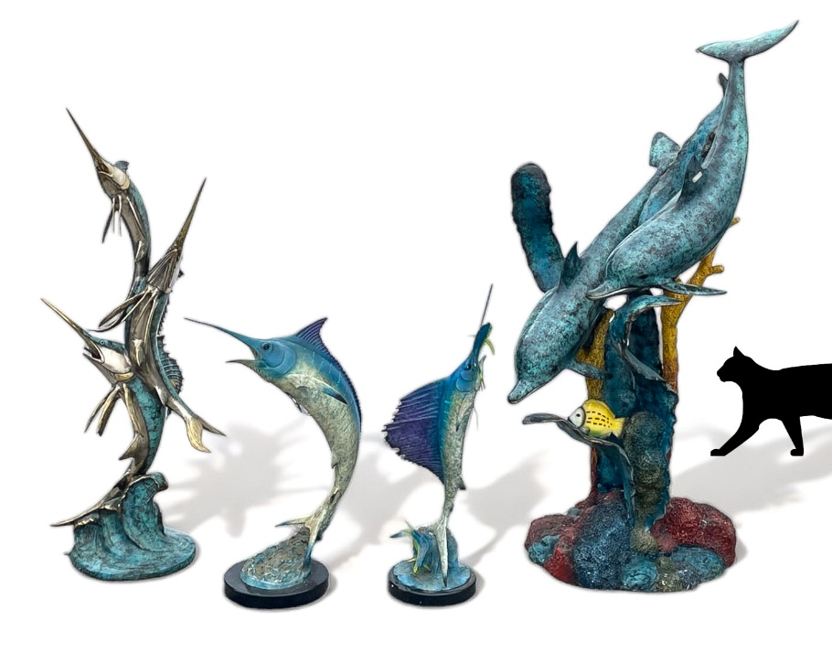

**Bronze Fountain & Statuary**

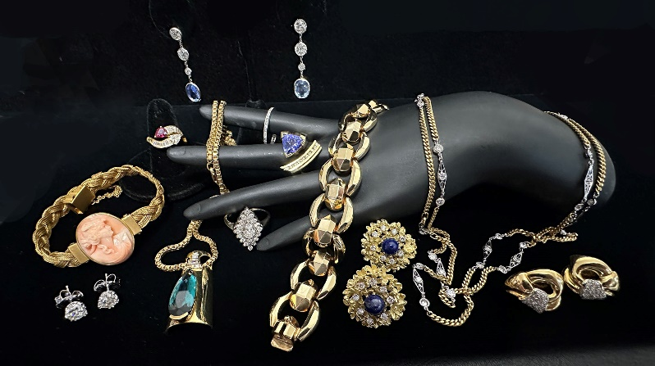

**Fabulous Assortment of Estate Jewelry**

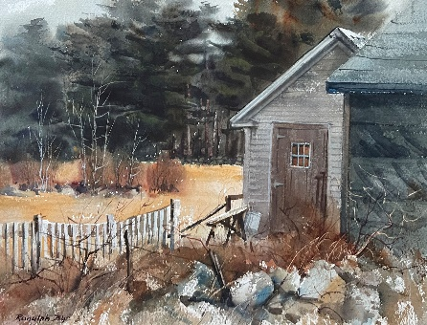

**1240) Ranulph Bye Watercolor**

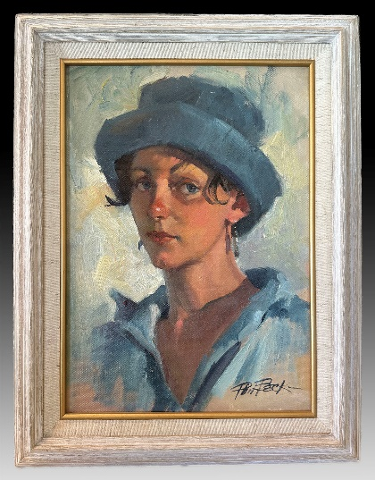

**1083) Phil Beck O/C**

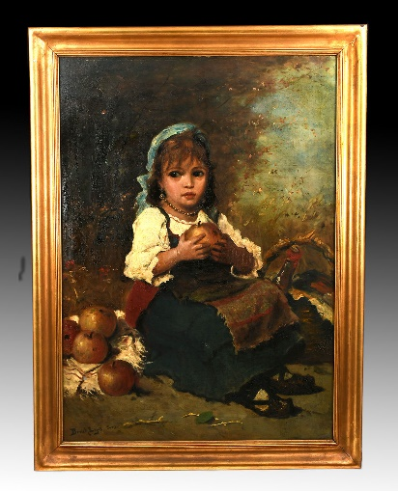

**1078) Lajos Bruck Oil on Canvas**

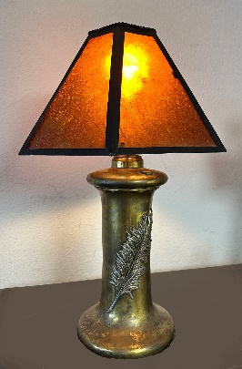

**Bradley & Hubbard Mica Shade Lamp**

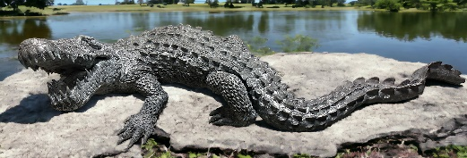

**7' Bronze Alligator**

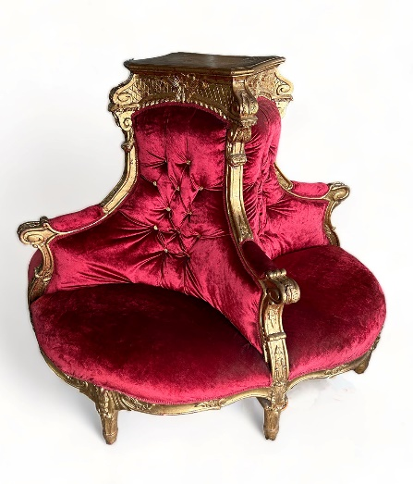

**1059) Triple Tufted Seat from the lobby of the Bellview Biltmore Hotel**

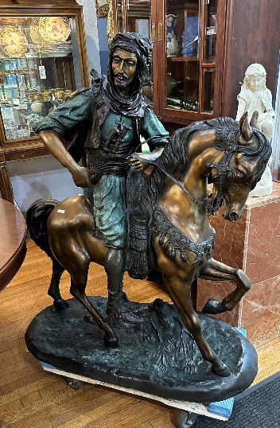

**1066) Large Bronze Arab on Horseback Sculpture After Antoine Louis Barye**

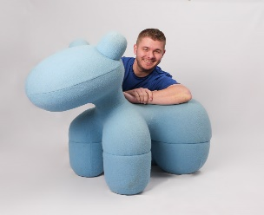

**1108) Eero Arnio Blue Pony Adult Toy Chair**

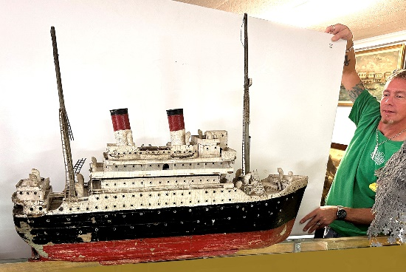

**Carved Wooden Ocean Liner**

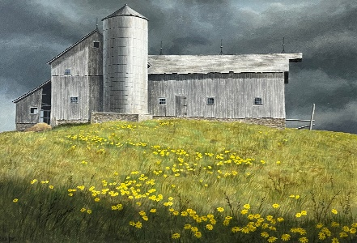

**1241) Russell Williams Tempera**

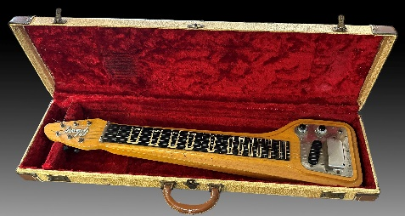

**Gibson Lap Guitar**

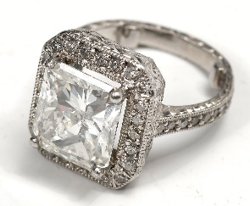

**1107) Luxurious 4.82 Ct Square Cut Solitaire Surrounded by Diamonds in Platinum $42,000 Appraisal**

Consignments Welcome BurchardGalleries.com mail@BurchardGalleries.com 727-821-1167 AU 322 AB 169